[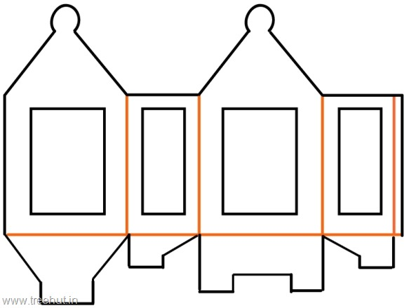](http://treehut.in/media/101/diwali-lantern-template-paper-craft-kids-large.jpg)